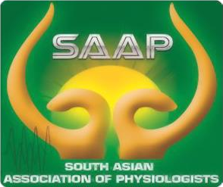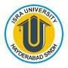 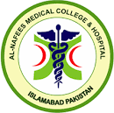 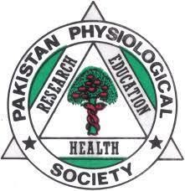

**Second Regional Journal Club**

**Pakistan Physiological Society**

**Rawalpindi & Islamabad Twin cities**

**Topic: The use of graded exercise test may be sufficient to quantify true changes in VO2 max following exercise training in unfit individuals with metabolic syndrome.**

Presenter: Dr Qazi Muhammad Faisal Rizwan PG Trainee MPhil

under supervision of Prof Dr Shazia Ali, Islamic International Medical College, Rawalpindi

Day/ Date: Wednesday, 24th April 2024.

Venue: Al- Nafees Medical College, Isra University Islamabad Campus, Lehtrar road, Farash town

Timings: 10:00 am to 11:00 am (20 minutes presentation and 40 minutes discussion time)

Mode: Hybrid (Zoom link will be shared later)

Moderador: Prof. Dr. Munazza Asad.

Closing remarks: Prof Dr Umar Ali Khan Pro Vice Chancellor Isra University

Participants:

All faculty of Physiology from Medical Colleges of Rawalpindi & Islamabad are cordially invited to attend the Journal club on above venue.

For any query: email at [munazza_wah@yahoo.com](mailto:munazza_wah@yahoo.com) 0r WhatsApp at 03335500566.